10.6 Claims Pricing And Adjudication Flowcharts

The following section contains flowcharts for the Claims Pricing and Adjudication Functional Area of the Claims Processing Subsystem. The flowcharts included in this section are:

- A high-level flowchart depicting the inputs and outputs of this functional area
- A flowchart of the Claims Entry/Correction process
- A flowchart of the Claim Control process
- A flowchart of the Claim Control Sub-Process 1
- A flowchart of the Claim Control Sub-Process 2
- A flowchart of the Claim Control Sub-Process 3
- A flowchart of the Claim Control Sub-Process 4
- A flowchart of the Claim Control Sub-Process 5
- A flowchart of the Claim Control Sub-Process 6
- A flowchart of the Claim Daily Adjudication Process 2 process
- A flowchart of the Electronic Media Claims (EMC) process
- A flowchart of the Mass Adjustment process
- A flowchart of the Suspense Release process
- A flowchart of the Daily Adjudication Report Cycle.

The flowcharts listed above begin on the next page.
10.6.1 Inputs and Outputs of the Claims Pricing and Adjudication Functional Area

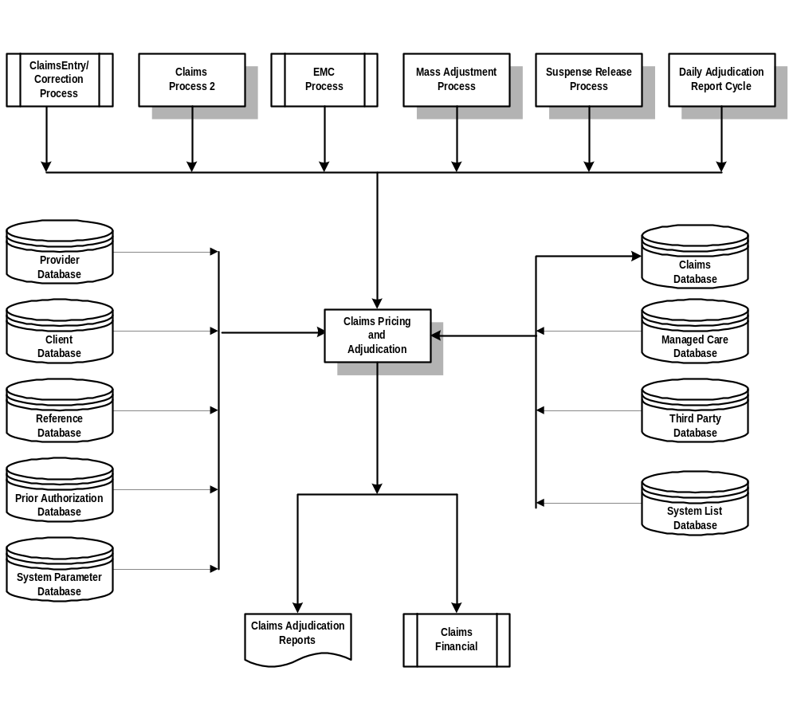

10.6.2. Claims Entry/Correction Process

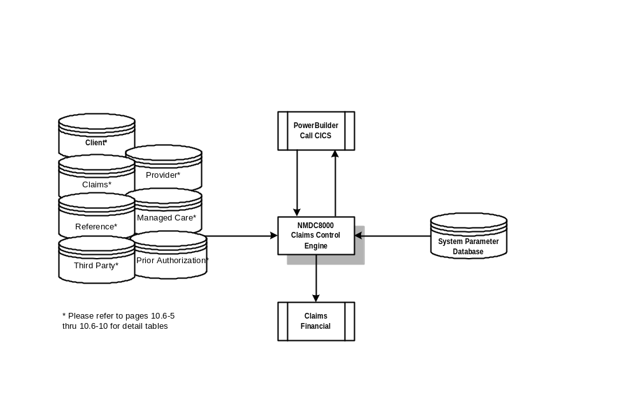

10.6.3. Claim Control Process

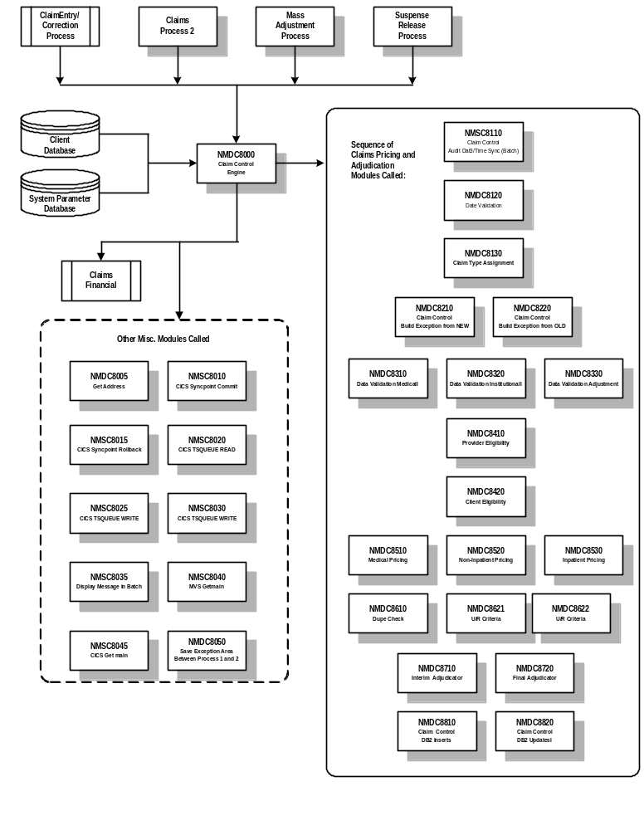
10.6.3.1 Claim Control Sub-Process 1 (Claim Type Assignment and Miscellaneous Processing)

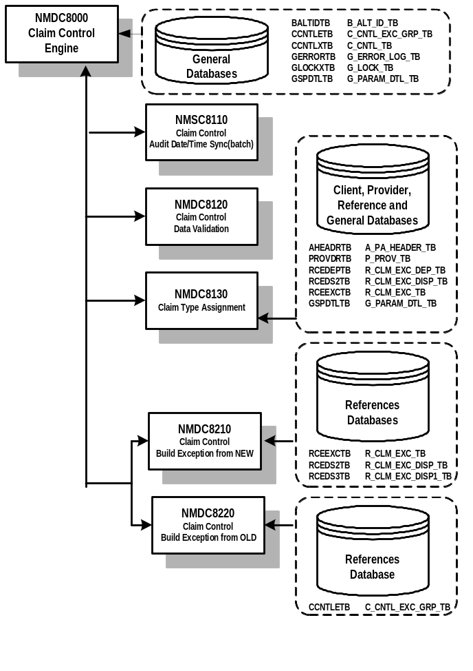

10.6.3.2. Claim Control Sub-Process 2 (Data Validation Edits and Grouper Call)
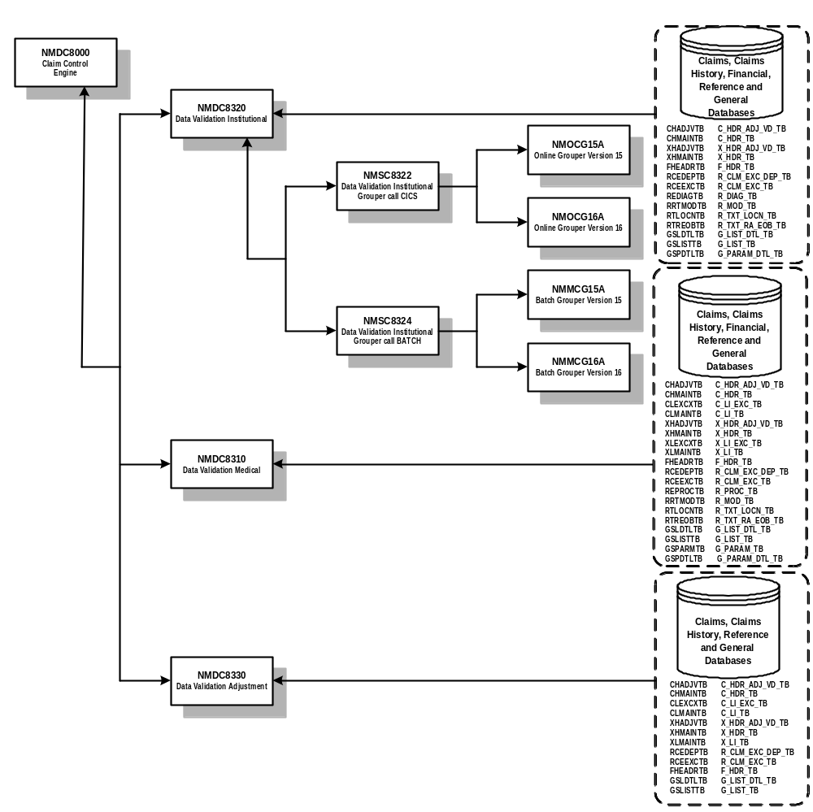

10.6.3.3. Claim Control Sub-Process 3 (Eligibility Edits and Category of Service Assignment)

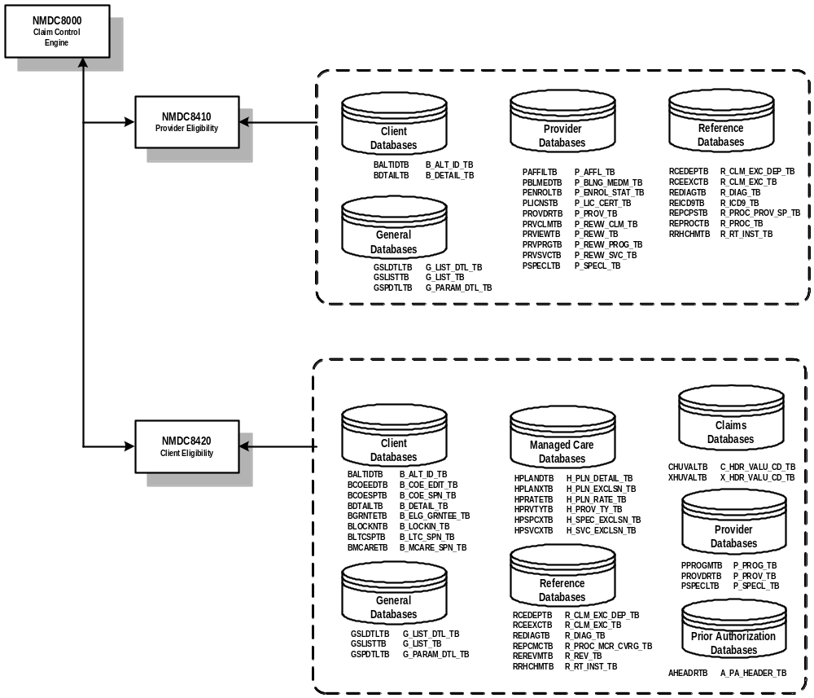

10.6.3.4. Claim Control Sub-Process 4 (Reference Edits, Pricing, PA Edits, and TPL Edits)

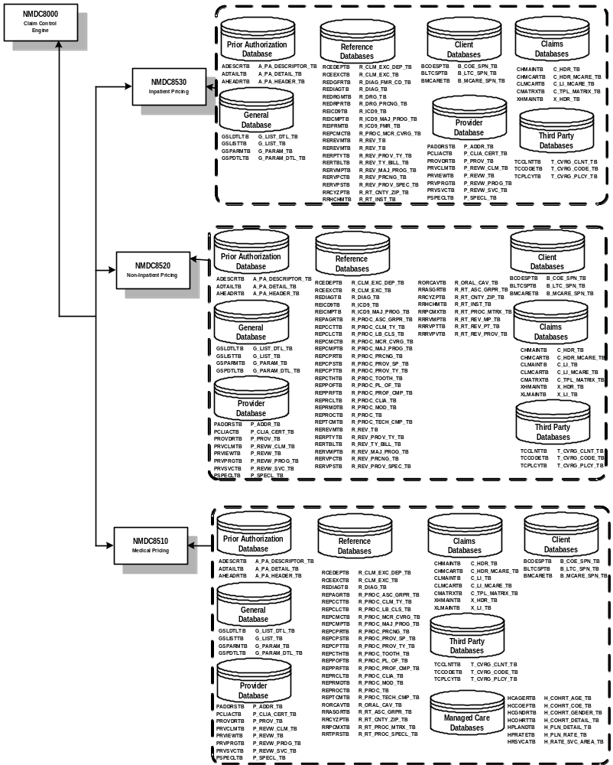
10.6.3.5. Claim Control Sub-Process 5 (Duplicate Check, UR Criteria, and Adjudication Processing)

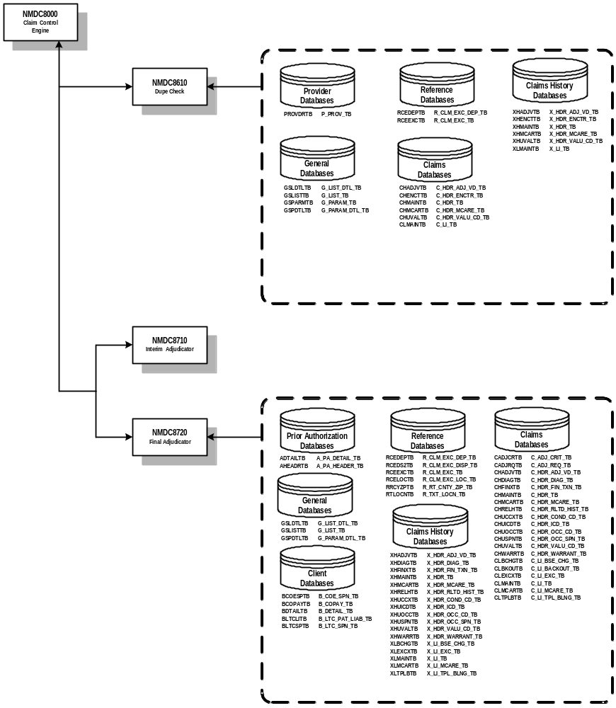
10.6.3.6. Claim Control Sub-Process 6 (Claim Add and Claim Update Functions)

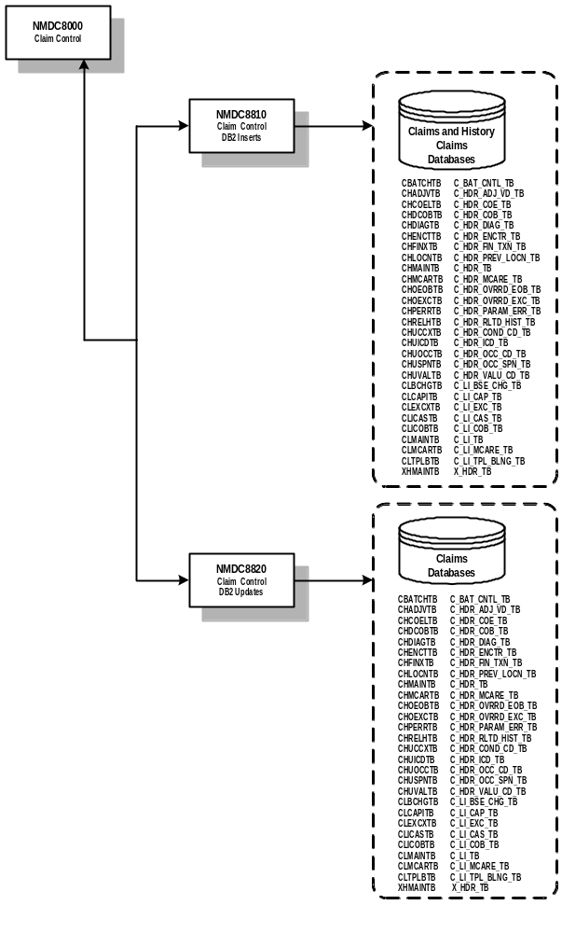
10.6.4. Claims Daily Adjudication Process 2

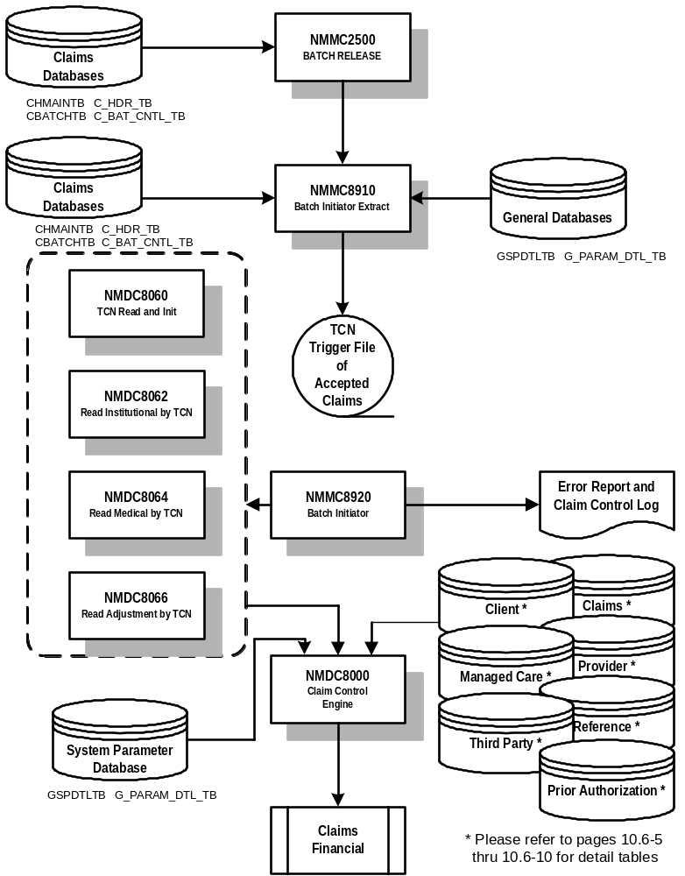

10.6.5. Electronic Media Claims (EMC) Process

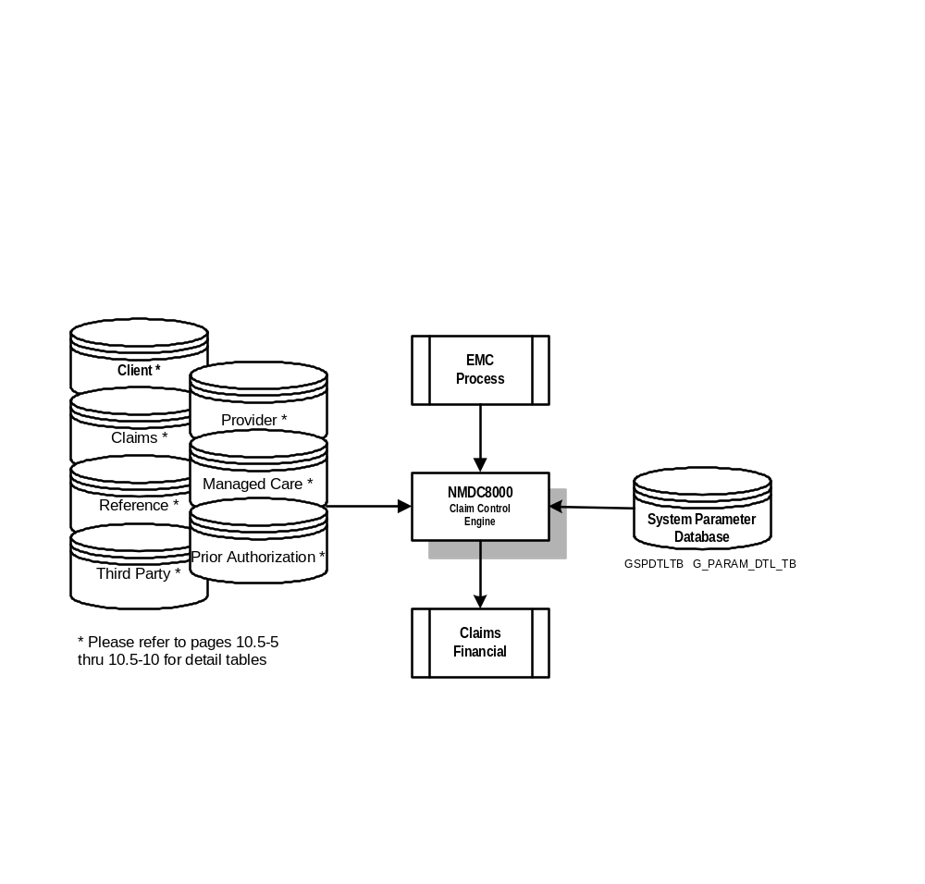

10.6.6. Mass Adjustment Process

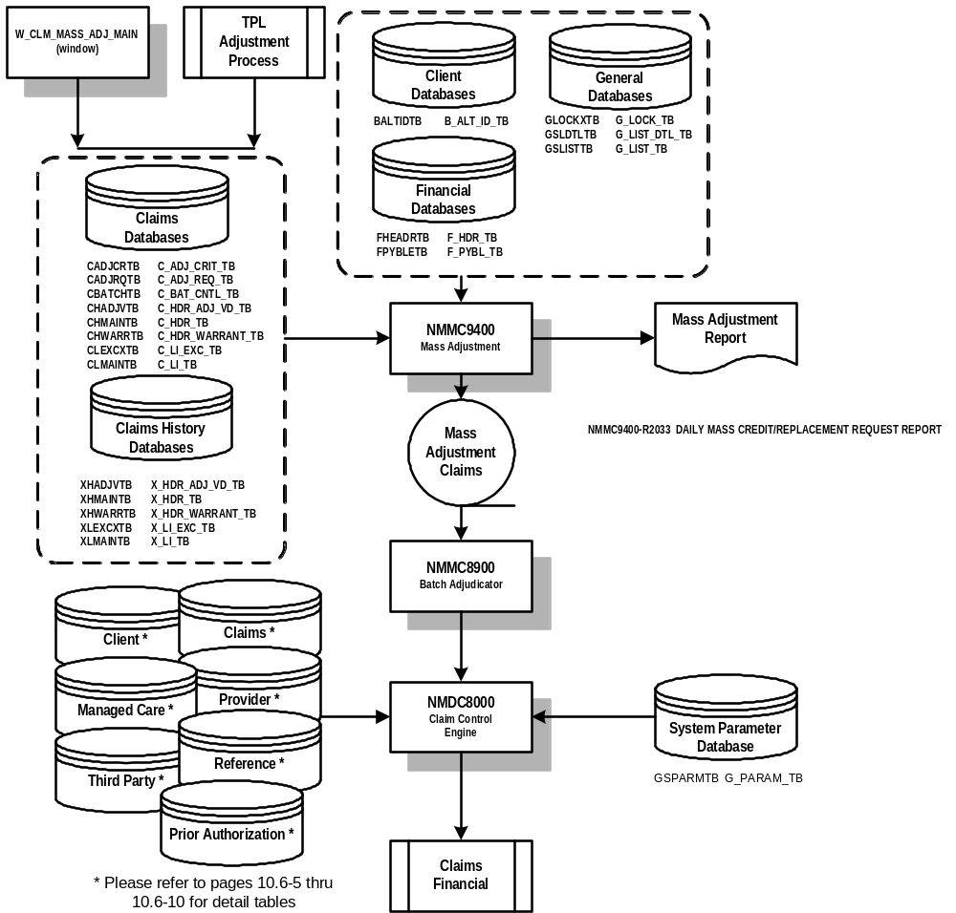

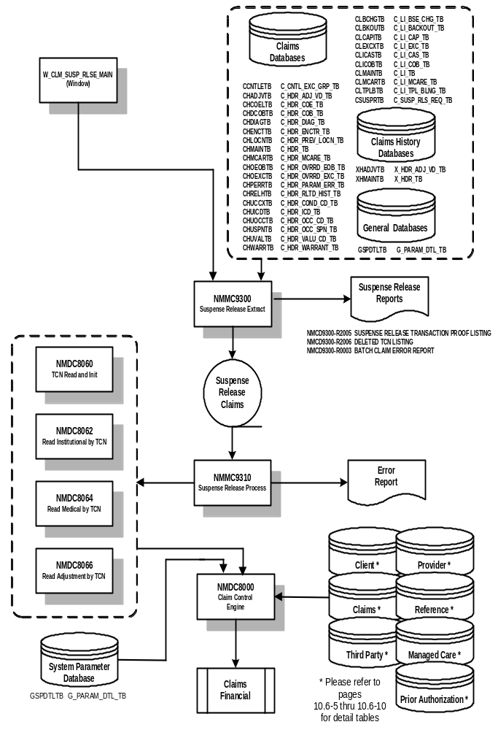10.6.7. Suspense Release Process

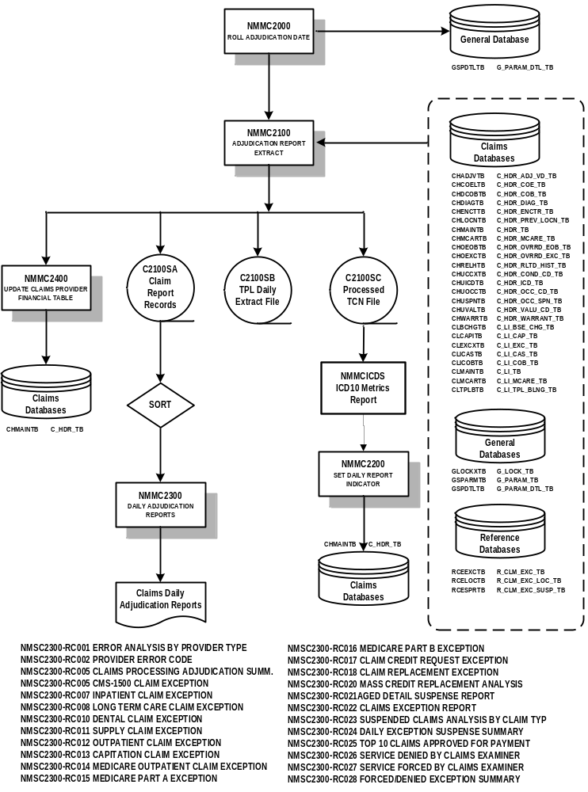10.6.8. Daily Adjudication Report Cycle

